**3. UML & USE CASES**

**3.1 Use Case Diagram**

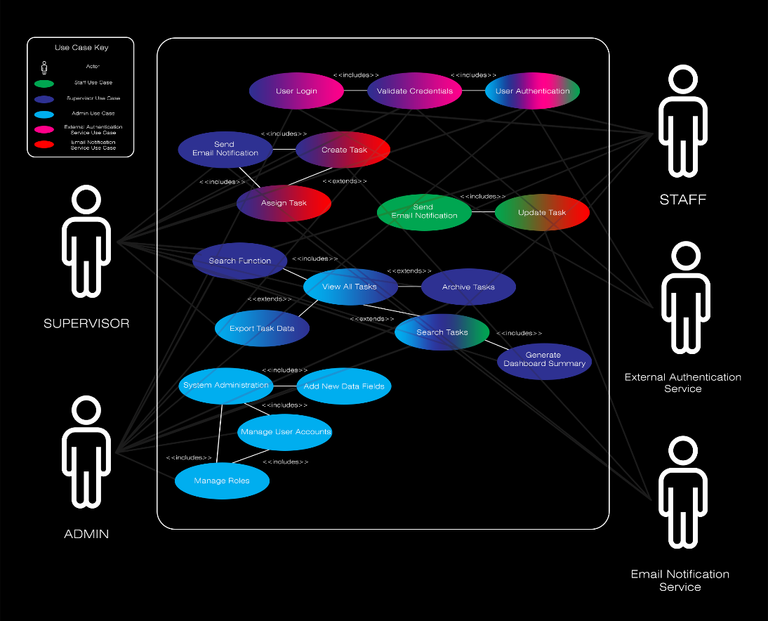

This Use Case Diagram provides a top-level view of the system’s functionality. This illustrates how each actor (Staff, Supervisor, Administrator, External Authentication Service, and Email Notification Service) interacts with various use cases. The use cases are color-coded by role to help visually distinguish which actions belong to which actor.

**3.2 Actors**

This table explains the purpose and basic background functionality of each actor’s privileges & features.

|  |  |
| --- | --- |
| Actor | Purpose |
| Staff | can view, update, manage their assigned tasks in each project. |
| Supervisor | has elevated responsibility which reflects in their privileges e.g create, assign, finalize tasks. Also has access to overview features. |
| Administrator | manages system configuration e.g user accounts, adding/editing projects. |
| External Authentication | handles login and credential validation via **Open Auth**. |
| Email Notification Service | sends notifications when tasks are created, assigned or updated. |

**3.3 Justification**

**Use Case 01: User Login**

The goal of this use case is to authenticate user logins & gain access to the system based on their role within the system. In case of invalid credentials, the system displays an error message and asks the user to retry.

Actors include: Staff, Supervisor, Administrator, External Authentication Service

Includes: **User Authentication**

**Use Case 02: User Authentication**

The goal of this use case is to authenticate any user login using an external authentication service such as **OpenAuth**.

Actors include: Staff, Supervisor, Administrator, External Authentication Service

Includes: **Validate Credentials**

**Use Case 03: Create Task**

The Supervisors can create new tasks, set details and can choose to assign Staff.

Actors include: Supervisor, Email Notification Service

Includes: **Send Email Notification** (automatically notifies staff)

Extends: **Assign Task** (optionally assign task to staff and send notification to those staff members)

**Use Case 04: Assign Task**

Supervisor can link a specific task to a Staff member which will define visibility to that user.

Actors include: Supervisor

Includes: **Send Email Notification** (alerts assigned staff members of the task)

Extends: **Create Task**

**Use Case 05: Update Task**

Staff updates the status or review date and adds progress notes to the rolling log for that project.

Actors include: Staff, Email Notification Service

Includes: **Send Email Notification** (alerts assigned staff members of the task)

**Use Case 06: View All Tasks**

Supervisors or Administrators view a full list of all tasks, with filtering and sorting tabs.

Actors include: Supervisor, Administrator

Includes: **Search Function**

Extends: **Export Task Data, Search Tasks, Archive Tasks**

**Use Case 07: Archive Tasks**

Supervisor or Administrator archives a task, will no longer be shown on the dashboard or available to any staff.

Actors include: Supervisor Administrator

Extends: **View All Tasks**

**Use Case 08: Export Task Data**

Users export tasks or project data to CSV for record-keeping.

Actors include: Supervisor, Administrator

Extends: **View All Tasks**

**Use Case 09: Add New Data Fields**

Administrator modify the task structure by adding new data fields like Priority Level.

Actors include: Administrator

Includes: **System Administration**

**Use Case 10: Manage User Accounts**

Administrator creates, updates or removes user accounts with any role.

Actors include: Administrator

Includes: **System Administration**

**Use Case 11: Search Tasks**

Users search by keyword or other data fields to quickly locate tasks.

Actors include: Staff, Supervisor, Administrator

Include: **Generate Dashboard Summary**

Extends: **View All Tasks**

**Use Case 12: Generate Dashboard Summary**

Shows statistics for aggregated functions e.g Number of Tasks, Users etc

Actors include: Supervisor, Administrator

Includes: **Search Tasks**

**Use Case 13: Manage Roles**

Change or Assign roles (Supervisor, Administrator, Staff) for new or existing users.

Actors include: Administrator

Includes: **Manage User Accounts**

**Use Case 14: Send Email Notification**

Sends users via email a notification when a task is created, assigned to them.

Actors include: Email Notification Service

Includes: **Update Task, Assign Task**

Extends: **Create Task**

**Use Case 15: Validate Credentials**

Takes user login details and validates them using external authentication service.

Actors Include: Staff, Supervisor, Administrator, External Authentication Service

Includes: **User Login, User Authentication**

**Use Case 16: Search Function**

Users search for tasks, projects using search bar with filtering

Actors include: Staff, Supervisor, Administrator

Includes: **View All Tasks**

**Use Case 17: System Administration**

Administrator access level has elevated permissions such as editing users, creating/editing data fields.

Actors include: Administrator

Includes: **Add Data Fields, Manage User Accounts, Manage Roles**